**isal hngm wviv ctfp**

{% **extends** "base.html" %}

{% **block** content %}

{% **if** form.errors %}

<**p**>Your username and password didn't match. Please try again.</**p**>

{% **endif** %}

{% **if** next %}

{% **if** user.is_authenticated %}

<**p**>Your account doesn't have access to this page. To proceed,

please login with an account that has access.</**p**>

{% **else** %}

<**p**>Please login to see this page.</**p**>

{% **endif** %}

{% **endif** %}

<**form** method="post" action="{% **url** 'login' %}">

{% **csrf_token** %}

<**table**>

<**tr**>

<**td**>{{ form.username.label_tag }}</**td**>

<**td**>{{ form.username }}</**td**>

</**tr**>

<**tr**>

<**td**>{{ form.password.label_tag }}</**td**>

<**td**>{{ form.password }}</**td**>

</**tr**>

</**table**>

<**input** type="submit" value="login">

<**input** type="hidden" name="next" value="{{ next }}">

</**form**>

*{# Assumes you set up the password_reset view in your URLconf #}*

<**p**><**a** href="{% **url** 'password_reset' %}">Lost password?</**a**></**p**>

{% **if** user.is_authenticated %}

<**p**>Welcome, {{ user.username }}. Thanks for logging in.</**p**>

{% **else** %}

<**p**>Welcome, new user. Please log in.</**p**>

{% **endif** %}

1. OCTYPE html>
2. <html>
4. <head>
5. <title>
6. Article on changing the color of the navbar in Bootstrap
7. </title>
9. <link href="https://cdn.jsdelivr.net/npm/Bootstrap@5.2.2/dist/css/Bootstrap.min.css" rel="stylesheet" integrity="sha384-Zenh87qX5JnK2Jl0vWa8Ck2rdkQ2Bzep5IDxbcnCeuOxjzrPF/et3URy9Bv1WTRi" crossorigin="anonymous">
10. </head>
12. <body>
13. <nav **class**="navbar navbar-dark bg-dark">
14. <a **class**="navbar-brand" href="#">
15. **this** background has dark color
16. </a>
17. </nav>
19. <nav **class**="navbar navbar-light bg-success">
20. <a **class**="navbar-brand" href="#">
21. This background has success color
22. </a>
23. </nav>
25. <nav **class**="navbar navbar-light bg-light">
26. <a **class**="navbar-brand" href="#">
27. This background has light color
28. </a>
29. </nav>
31. <nav **class**="navbar navbar-dark bg-secondary">
32. <a **class**="navbar-brand" href="#">
33. This background has secondary color
34. </a>
35. </nav>
37. <nav **class**="navbar navbar-dark bg-primary">
38. <a **class**="navbar-brand" href="#">
39. This background has primary color
40. </a>
41. </nav>
43. <nav **class**="navbar navbar-dark bg-warning">
44. <a **class**="navbar-brand" href="#">
45. This background has warning color
46. </a>
47. </nav>
49. <div **class**="container">
50. <h1 style="color: rgb(2, 231, 2)">Javatpoint</h1>
51. <b>
52. changing the nav bar color **using** **class** names in bootstrap
53. </b>
55. <p>There are some bars above which have different colors depending on the **class** used.</p>
57. </div>
58. </body>
60. </html>

**Output:**

<div class="text-bg-primary p-3">Primary with contrasting color</div>

<div class="text-bg-secondary p-3">Secondary with contrasting color</div>

<div class="text-bg-success p-3">Success with contrasting color</div>

<div class="text-bg-danger p-3">Danger with contrasting color</div>

<div class="text-bg-warning p-3">Warning with contrasting color</div>

<div class="text-bg-info p-3">Info with contrasting color</div>

<div class="text-bg-light p-3">Light with contrasting color</div>

<div class="text-bg-dark p-3">Dark with contrasting color</div>

| **Class** | **Heading** | **Heading** |
| --- | --- | --- |
| **Active** | Cell | Cell |
| **Default** | Cell | Cell |
| **Primary** | Cell | Cell |
| **Secondary** | Cell | Cell |
| **Success** | Cell | Cell |
| **Danger** | Cell | Cell |
| **Warning** | Cell | Cell |
| **Info** | Cell | Cell |
| **Light** | Cell | Cell |
| **Dark** | Cell | Cell |

Copy

<!-- On rows -->

<tr class="table-active">...</tr>

<tr class="table-primary">...</tr>

<tr class="table-secondary">...</tr>

<tr class="table-success">...</tr>

<tr class="table-danger">...</tr>

<tr class="table-warning">...</tr>

<tr class="table-info">...</tr>

<tr class="table-light">...</tr>

<tr class="table-dark">...</tr>

<!-- On cells (`td` or `th`) -->

<tr>

<td class="table-active">...</td>

<td class="table-primary">...</td>

<td class="table-secondary">...</td>

<td class="table-success">...</td>

<td class="table-danger">...</td>

<td class="table-warning">...</td>

<td class="table-info">...</td>

<td class="table-light">...</td>

<td class="table-dark">...</td>

</tr>

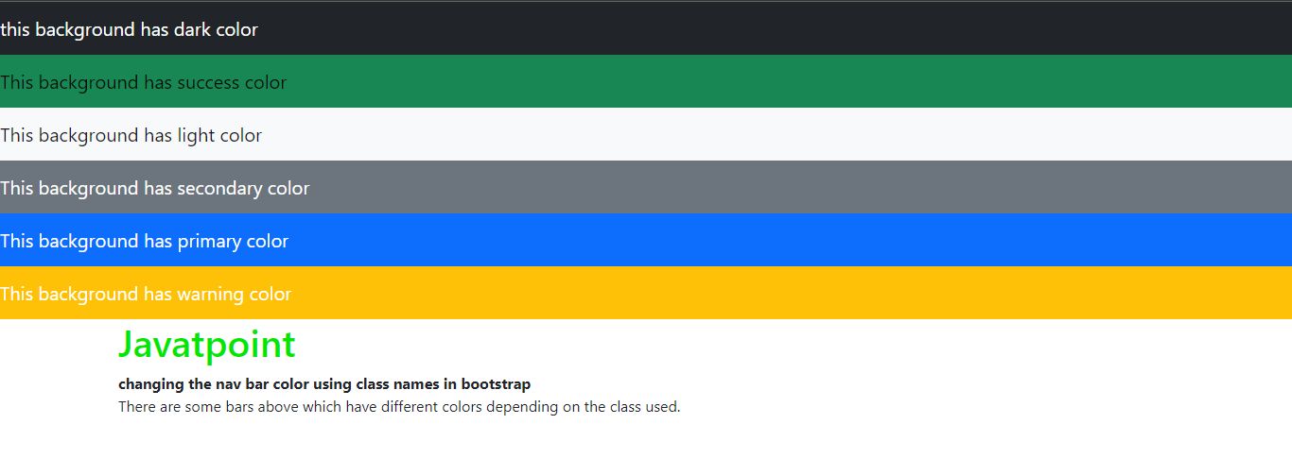

**Explanation**

In the above article, we have taken different bars and set the different colors by changing their class names. For each nav bar, we have defined inbuilt class names, which will set their colors accordingly.

Method 2:

We can manually style the navigation bar using the background color property of CSS.

Example 1:

1. <!DOCTYPE html>
2. <html>
4. <head>
5. <title>
6. Article on changing the color of the navbar in Bootstrap
7. </title>

10. <link href="https://cdn.jsdelivr.net/npm/Bootstrap@5.2.2/dist/css/Bootstrap.min.css" rel="stylesheet" integrity="sha384-Zenh87qX5JnK2Jl0vWa8Ck2rdkQ2Bzep5IDxbcnCeuOxjzrPF/et3URy9Bv1WTRi" crossorigin="anonymous">

13. <style>
14. .navbar-custom {
15. background-color: rgb(193, 201, 193);
16. }
18. .navbar-custom .navbar-brand,
19. .navbar-custom .navbar-text {
20. color: rgb(102, 13, 245);
21. }
22. </style>
23. </head>
25. <body>
26. <nav **class**="navbar navbar-custom">
27. <a **class**="navbar-brand" href="#">
28. Custom color background navbar in Bootstrap
29. </a>
30. </nav>
32. <div **class**="container">
33. <h1 style="color: rgb(11, 236, 11)">Javatpoint</h1>
34. <b>changing the nav bar color **using** **class** names in Bootstrap</b>

37. <p>For the above navigation bar, we will use the custom **class** and style it with CSS property.</p>
39. </div>
40. </body>
42. </html>